Freezer Temperature Early Warning WiFi/Text

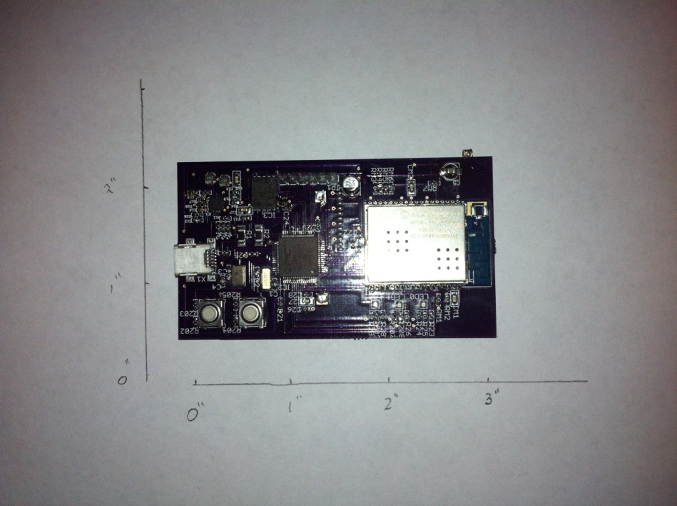

Parts:

Board: OshPark.com

~ $30.00 per 3 boards $10.00/brd

ICs plus Passive Components: DigiKey.com

~$350.00 per 5 boards $70.00/brd

Custom enclosure (Knick machining)

~$250.00 per 10 boxes $25.00/box

Labor

$20.00/brd

___________________________________________________________

Total $125.00/box

Generally boards would be made in batches of five and would require about two-three weeks from start to finish. When everything is in stock a day is required to manufacture.

A single unit would monitor four coolers that are close together.

# Electronic Realization llc

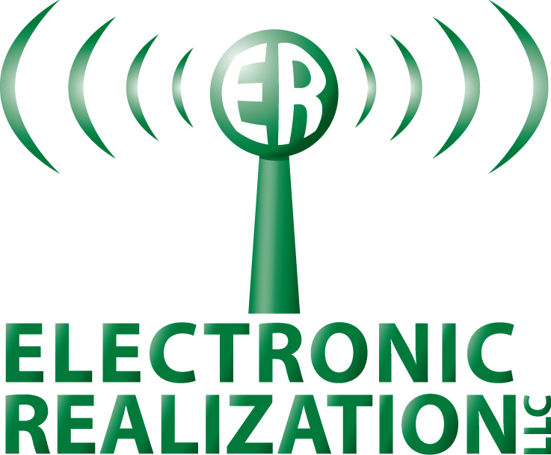

P.O. Box 191

Bozeman,MT 59771-0191

USA

Phone (406) 577-2712

cell (406) 539-8117

E-mail cy@elec-real.com

Web site www.elec-real.com